*This document was written on 20.03.2018*

# Table of contents

Table of contents 1

JDK 2

Maven 9

# JDK

1. From <https://www.oracle.com/technetwork/java/javase/downloads/jdk8-downloads-2133151.html> download & install jdk-8u111-windows-x64.exe to c:\programs\Java\jdk8 and c:\programs\Java\jre8

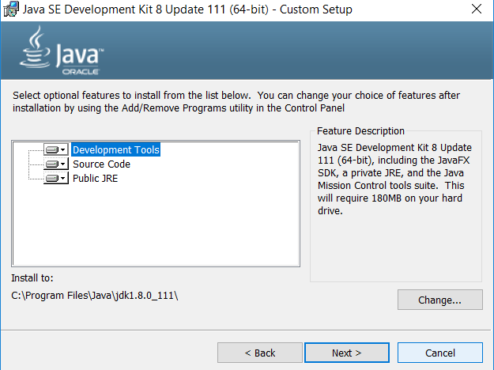v

* Click on Change.. button. Change path to c:\programs\Java\jdk8

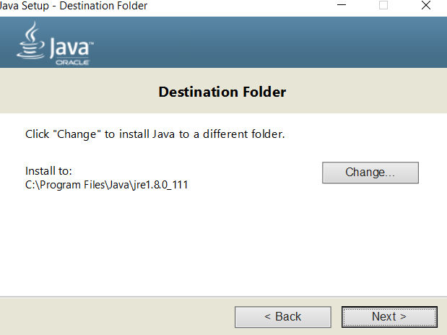

* Click on Change.. button. Change path to c:\programs\Java\jre8.
* Go to Startup (applications)

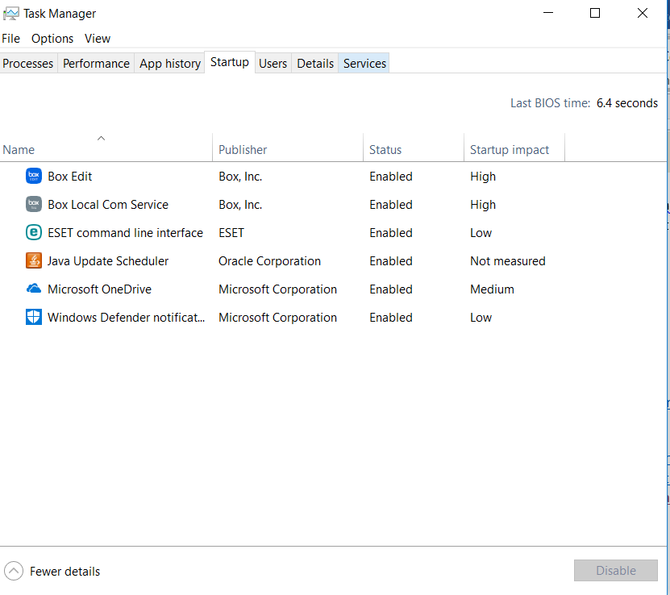

And **disable Java Update Scheduler.**

* Go to environment variables

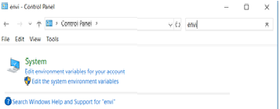

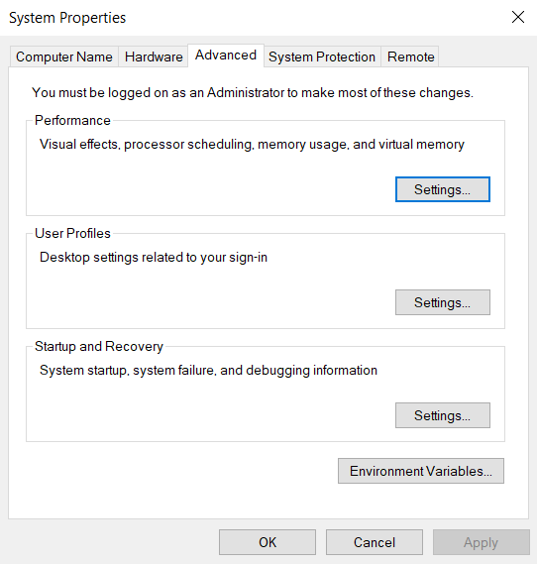

* Click on Environment Variables
* Go to System variables section.
* Create new variable JAVA_HOME that points to c:\programs\Java\jdk8

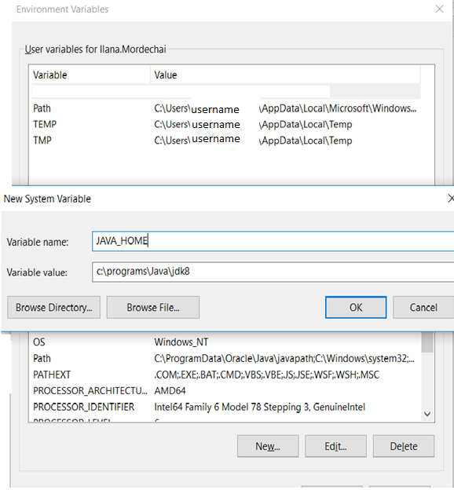

* Click ok
* Search for **Path** variable in the “**System Variable**” section in “Environment Variables” dialogue box you just opened. Click on Edit button.

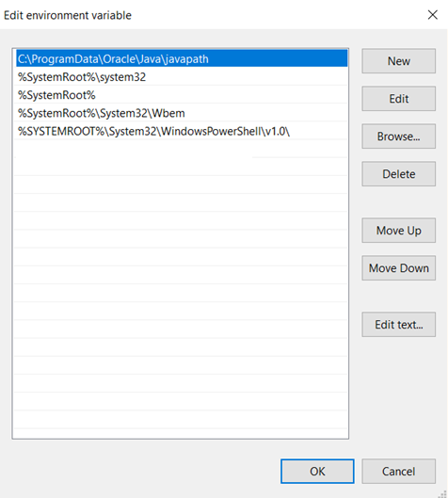

* Find C:\ProgramData\Oracle\Java\javapath entry. Click on Edit. Change it to %JAVA_HOME%\bin
* Click ok.
* To confirm your Java installation just open cmd and type java -version , you should be able to see version of the Java you just installed.

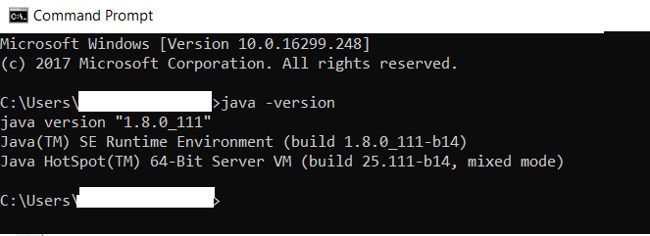

# Maven

* From <https://www.apache.org/dyn/closer.cgi?path=maven/maven-3/3.3.9/binaries/apache-maven-3.3.9-bin.zip> download and extract apache-maven-3.3.9-bin.zip to c:\programs\
* Rename c:\programs\apache-maven-3.3.9 to **c:\programs\maven**
* Extract apache-maven-3.3.9-src.zip to c:\programs\maven.

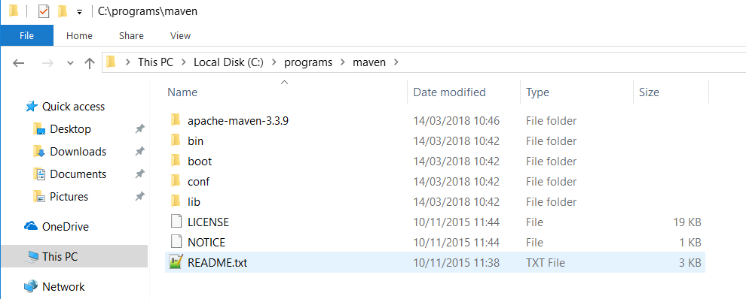

* Search for Path variable in the “**System Variable**” section in “Environment Variables” dialogue box you just opened.



* Click on Environment Variables
* Go to System variables section.
* Click ok
* Search for **Path** variable in the “**System Variable**” section in “Environment Variables” dialogue box you just opened. Click on Edit button.
* Go to environment variables





* Click on Environment Variables
* Go to System variables section.
* Click ok
* Search for **Path** variable in the “**System Variable**” section in “Environment Variables” dialogue box you just opened. Click on Edit button.
* Click New button and add c:\programs\maven\bin\

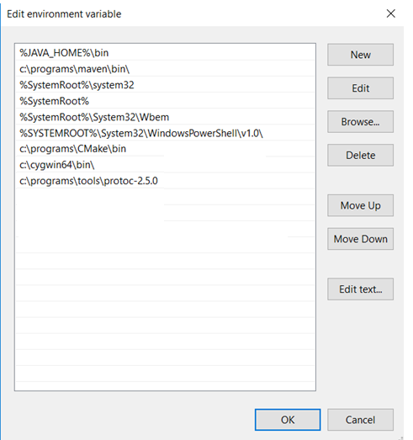

* Click ok.
* Click ok.
* To confirm your Maven installation just open cmd and type mvn -version, you should be able to see what version of Maven you just installed.
* Run also mvn clean (it creates %USERPROFILE%\.m2 directory).
* Go to Box and **download settings.xml.**
* **Put it to %USERPROFILE%\.m2**

